Perfect Competitive Markets

1. Fragmentation
2. Products are undifferentiated
3. Consumers have perfect information about price
4. Firms have equal access to all necessary resources

If these characteristics are present than

1. Buter and seller are price takers (i.e., price is determined by the interaction of all market participants)
2. There will be one price: the law of one price (i.e., the price would become one price at the end)
3. There is free entry

Assume firms maximize profit:

- costs: TC(Q)

- revenue TR(Q) = pQ

where p>0 is the price

max = TR(Q) – TC(Q)

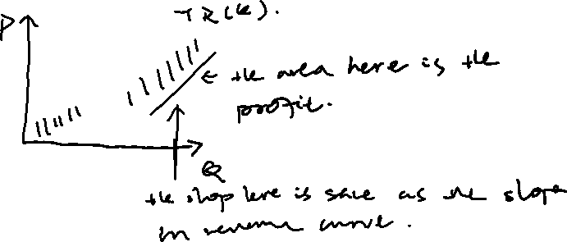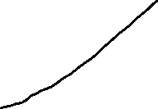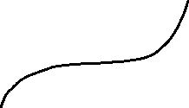

- to maximize profit if the solution is inferior, marginal profit will be zero.

d(pQ-TC(Q))/dQ = 0

P- MC(Q) = 0

On point B:

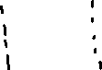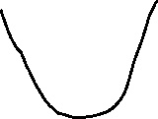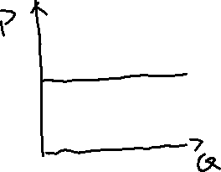

The total revenue is maximized, P = MC(Q)

Short run supply curve

STC(Q) (short total cost)

= TVC(Q) +SFC (sunk fixed cost) +NSFC (non-sunk fixed cost) if Q>0

= SFC if Q = 0

- if we produce, set Qk wo that MC(Qk) = p and MC(Qk) is increasing

- now compare this with Q = 0: profit at shutdown are -SFC

- firm choose Qk if (pQk – TVC(Qk) – SFC- NSFC) >= -SFC